Activity 3: Basic pancake recipe

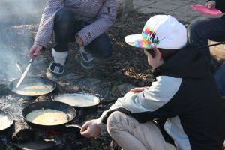
Makes about 16 pancakes
Ingredients:
- 2 eggs
- 200 g flour (1½ cups)
- Pinch salt
- 550 ml milk (2½ cups)

Put ingredients into a blender in this order: 2 eggs, 200 g flour, pinch salt, 550 ml milk. Whizz it wisely, whizz it well for 1 minute to make a thin pancake batter. Let it stand for half an hour.
Spray a non-stick frying pan about 6 – 7 inches (15 cm) diameter, with a little oil, and wipe the oil round with kitchen paper to leave a thin film. Put the pan onto the fire and let it get hot, until you can see very hot. A drop of batter should set immediately.
Carefully pour in some batter, not too much, and swirl it round quickly. Let it cook for at minute or two, until the underside is set and browned. Keep shaking it, to prevent sticking. Your might need to use a fish slice to set it free. When you’re ready, toss or flip it over, and give the other side another minute or so to cook. Then tip the pancake on to a waiting plate.
On to the next pancake! Wipe the pan round with oily kitchen paper - remember to take care – to reprime* the surface, bring it back up to heat, and off you go again.

* Reprime – spæde på igen

