Activity 6: The History of Pancake Day – 2

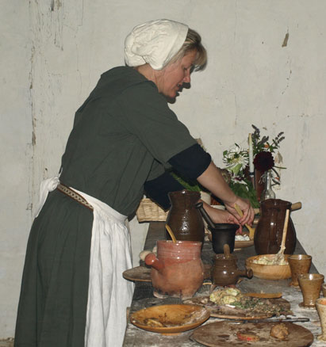

Shrove Tuesday (Pancake Day) gets its name from the Christian ritual of shriving.
In shriving, a person confesses their sins and receives pardon for them. When a person receives pardon for their sins, the person was forgiven and released from the guilt and pain.
Shrove Tuesday is a day of Celebration as well as repentance, because it is the last day before Lent. Lent is the name used for the 40 days before the death of Jesus Christ.
Shrove Tuesday was the last chance to spoil oneself, and use up the foods that were not allowed to eat during Lent.
In the old days there were many foods that Christians would not eat during Lent: such as meat and fish, fats, eggs and milky foods. So that no food was wasted, families would have a feast on the shriving Tuesday and eat up all the food.

