Aktivitetsark 5: Hvorfor går man på jagt?
Ja hvorfor? Spørg en jæger.

Her kan du skrive de spørgsmål du vil stille - og nogle af de svar, du får:

 ______________________________________
___________________________________________________

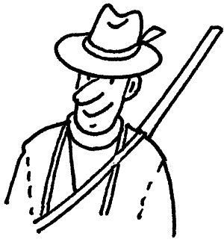 ______________________________________
___________________________________________________
___________________________________________________
___________________________________________________

______________________________________
___________________________________________________

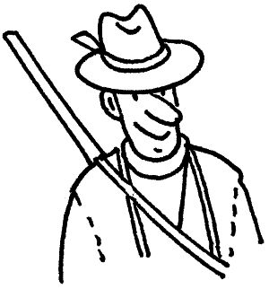 ______________________________________
___________________________________________________
___________________________________________________
___________________________________________________
___________________________________________________

Du kan fortsætte på bagsiden af papiret.

______________________________________
___________________________________________________

______________________________________
___________________________________________________
___________________________________________________
___________________________________________________

______________________________________
___________________________________________________

______________________________________
___________________________________________________
___________________________________________________
___________________________________________________
___________________________________________________

Navn: ______________ Klasse: ______________ Dato: ______________ Sted: ______________

